Med D - Accessing MARx

General Information
Registration and Creating a New ID and Password
Logging into MARx
How to Request Access to an Application and a Role
How to Add Access to an Application and a Role for Another Line of Business
How to Register a Multi Factor Authentication (MFA) Using an Email Address
Log Activity
Resolution Time
Related Documents

Description: This document outlines the process of requesting access to the MARx system, adding a role and registering for the MARx system.

General Information
CMS has established an Identity Management (IDM) secure website or portal (https://portal.cms.gov/portal/) providing a means to apply for, obtain approval, and receive a single User ID to access the Medicare Advantage and Part D Inquiry System Online Operations (MARX) application.

This CMS Enterprise Portal User Manual provides assistance, quick overviews, and basic step-by-step instructions on how to register for a User ID and password, applications and roles, and how to submit requests for access to applications supported by IDM. Refer to Guides and Documentation Web site.

If you already have access to MARx, refer to MED D - Verifying Enrollment, Eligibility and LIS in MARx.
Top of the Document

Registration and Creating a New ID and Password
Note: This is a two-step process.

Refer to Section 2 of the CMS Enterprise Portal User Manual.

The CCR will follow the steps below to register and create a new ID and password:
Step | Action
1 | Access the CMS site at the following link: https://portal.cms.gov/portal/  Result: The CMS.gov Enterprise Portal page will display.  Note: If you already have access to MARx you DO NOT have to register as a New User. You will log in using your existing User ID and Password and follow the Step-by-Step instructions in MED D - Verifying Enrollment, Eligibility and LIS in MARx.
2 | Click on New User Registration.  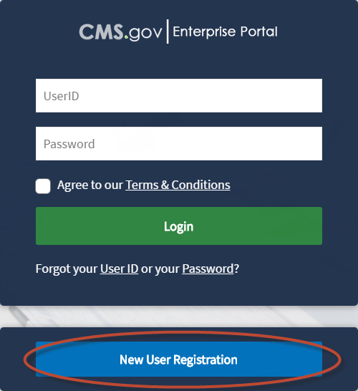
3 | Select the following Application - MARx – Medicare Advantage & Prescription Drug System.  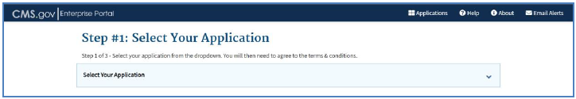
4 | Check the box. “I agree to the terms and conditions”.
5 | Select Next.
6 | Fill in the following fields:  - First Name – Must match the First name exactly as listed in the Directory  - Last Name – Must match the Last name exactly as listed in the Directory  - Date of Birth  - Home Address  - E-mail Address - Your email address exactly as listed in the Directory  - Confirm Email Address  - Primary Phone Number (work phone number)  - Some fields are optional and not required.  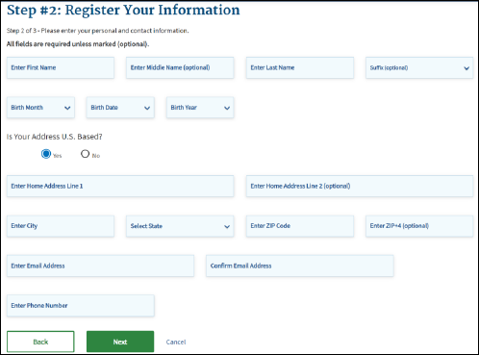
7 | Select Next.
8 | Choose and enter the User ID and Password based on system requirements.  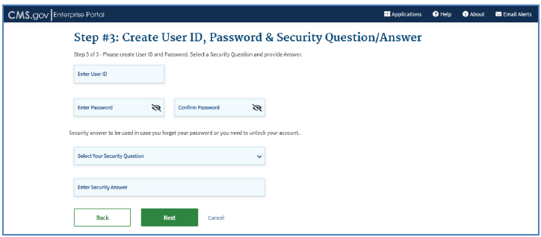
9 | Select Challenge Questions and Answers.
10 | Select Next to complete the registration process.  Result: The following page will display  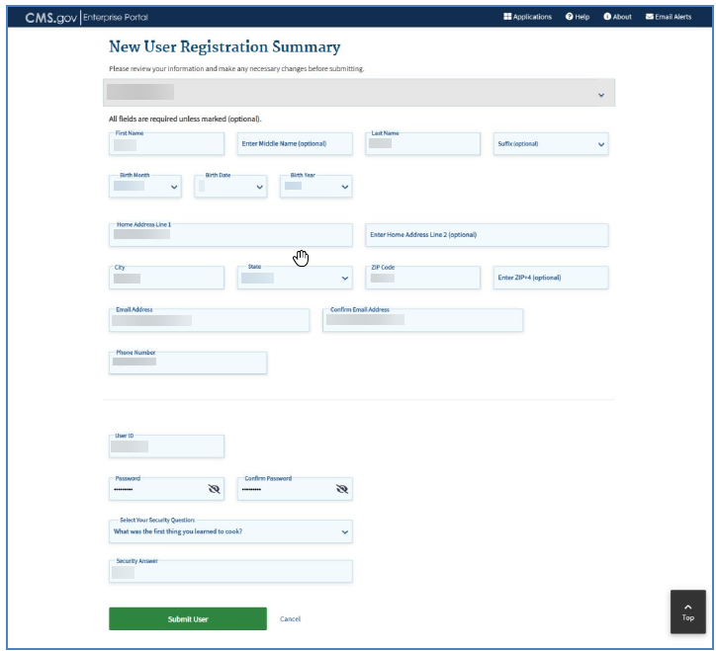
11 | Click the Submit User button.  Result: The following page will display.  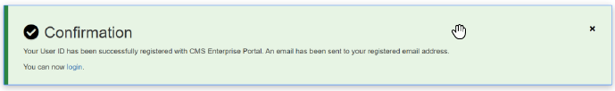
12 | Open email from CMS <donotreply@cms.gov>:  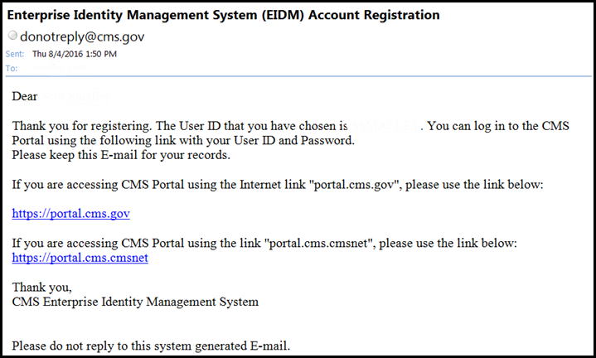

Top of the Document

Logging into MARx

Follow the steps below to log into MARx:
Step | Action
1 | Access the CMS site at the following link: https://portal.cms.gov/portal/  Result: The CMS.gov Enterprise Portal page will display.
2 | Enter the following information and Select Login.  - Marx User ID and password.  - Place a check in the Agree to our Terms & Conditions checkbox.  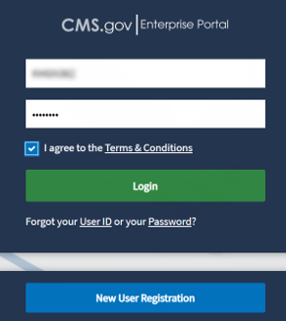  Note: To request access for MARx, refer to Registration and Creating a New ID and Password.
3 | Select Email from Multi-Factor Authentication drop down box.
4 | Select Send MFA Code.  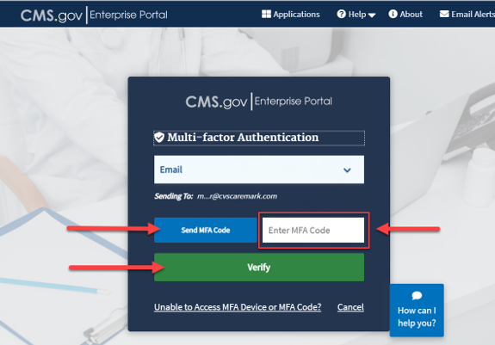  Notes:  - A MFA code will be sent to your email from IDM Auto Response (no-reply@idm.cms.gov).  - The MFA code will expire in 30 minutes.
5 | Enter the MFA code and Select Verify.  Notes:  - CCRs have the option to Select Re-send MFA Code if the MFA Code email is misplaced.  - If unable to access MFA Device or Security code, select Unable to Access MFA Device or MFA Code for additional information on help desk contact information.  Result: The My Portal screen will display.
6 | Select MARx UI tile and then MARx UI Application link.  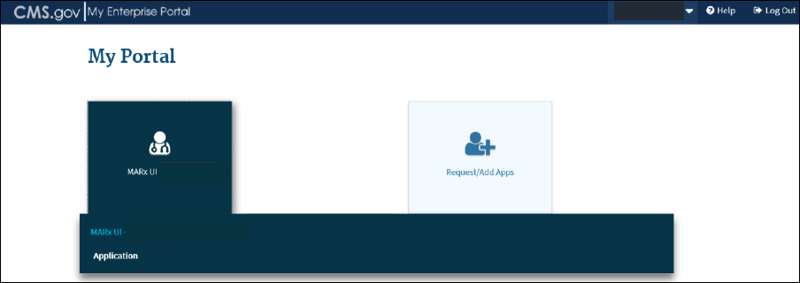  Result: The Medicare Advantage Prescription Drug (MARx) User Security Role Selection screen will display.
7 | Click Logon with Selected Role.  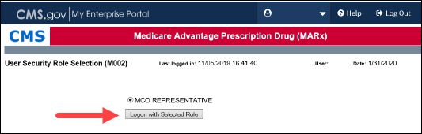

Top of the Document

How to Request Access to an Application and a Role

Follow the steps below to request access to an application and a role:
Step | Action
1 | Log into MARx. Refer to Logging into MARx.
2 | Select Add Application to continue.  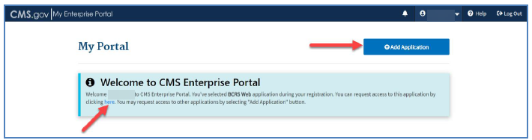
3 | Under the Select an Application drop down, select MARx – Medicare Advantage & Prescription Drug System and select Next.  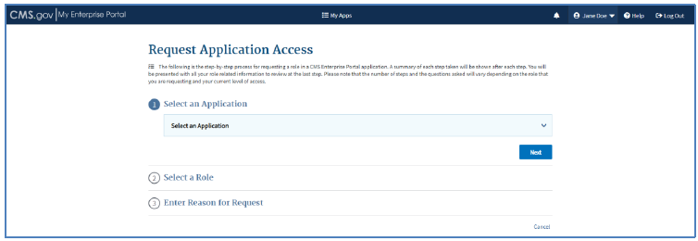
4 | Under Select a Role drop down, select PDP Representative and select Next.
5 | Click Launch to begin the Identify Verification Process.  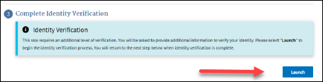
6 | Read the information on the screen then click Next.  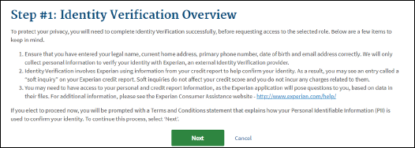
7 | - Read and Accept the Terms and Conditions.  - Click Next.  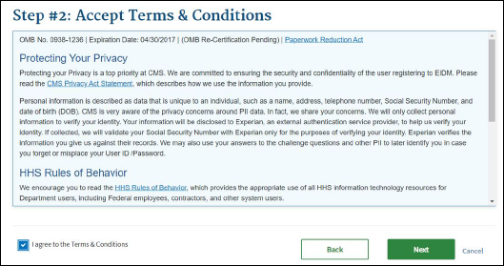
8 | Enter your information into the required fields and select Next.  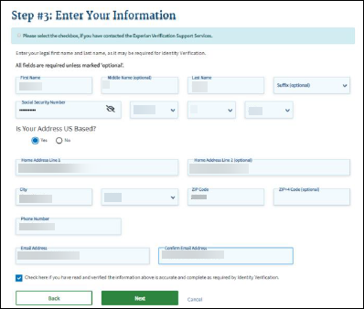
9 | - Review the list of verification questions that will show to verify the identity of the CCR.  Note: These questions will be based on information within public records. The purpose of these questions is to verify the identity of the applicant. This is NOT a credit check. This information is provided to CMS, a governmental organization, only.  - Select the appropriate answers and click Next.  Example:  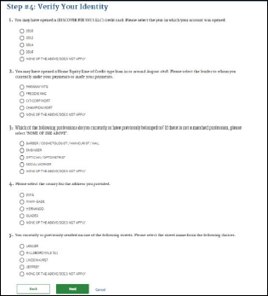
10 | Click Next.  Result: Set up is now complete and the Multi-Factor Authentication Information screen opens.
11 | Click Next.  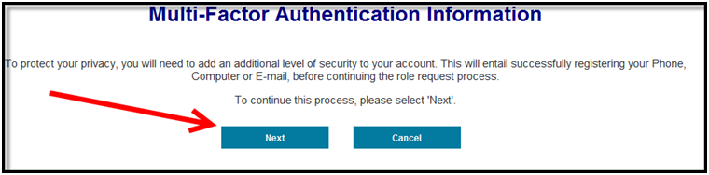
12 | - Select Email in the drop down MFA Device Type box.  - Click Next.  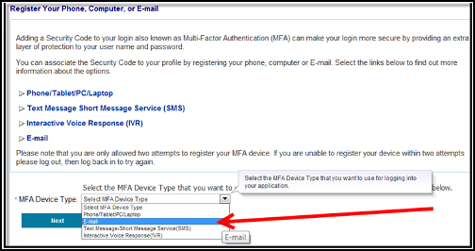  Result: Another text box will populate.
13 | - Enter the email address (Your work email address exactly as listed in the Directory) and MFA Device description (ex. Work Email)  Note: You are only allowed two attempts to register your MFA device. If you are unable to register your device within two attempts, log out, then log back in to try again.  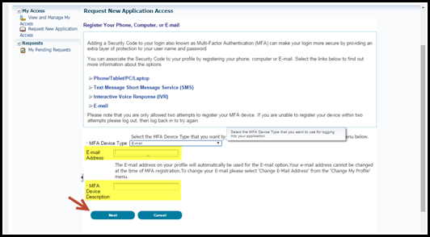  - Click Next.  Result: Confirmation page will display.
14 | Click Next.  Note: If you cannot verify with the questions, you will receive the following message stating “We were unable to verify the information…”  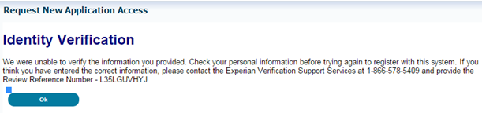
15 | - Complete the information requested with an asterisk.  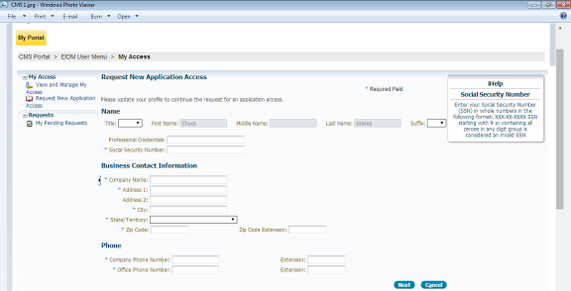  - Social Security Number: Use your social security number.  - Company Name: Use SilverScript  - Company Address: Use the address for your site. If WFH, use the site you are based at.  - Company Phone Number: Site Telephone Number  - Office Phone Number: Site Telephone Number  - Click Next.  - Application Description: MARx – Medicare Advantage & Prescription Drug System  - Role: PDP Representative  - Plan Contract Number:  - S5601 = SilverScript  - S2893 = Blue MedicareRx (NEJE CCRs Only)  - Reason for Request: Needed For Role.  - Click Next.  Result: You will receive confirmation email for the Contract ID in your Email account. Check your email 2-3 business days after you have submitted this request to confirm your access was granted. If your access was denied, inform your supervisor/facilitator immediately for assistance.
16 | Click Submit.  Result: The Request New Application page is displayed.
17 | Review the information displayed.  Note: Select Edit to modify the information. If the “Please update your profile…” message is displayed, enter the required information and then select Next.
18 | Click Submit to submit the request for approval.  Result: After selecting Submit, the Request New Application Access Acknowledgement page is displayed  Note:  - The acknowledgement page displays the tracking number for the request and informs you that you will receive an email when the request has been processed.  - A series of two emails will be sent:  - First email is a confirmation for each Contract Number entered during request.  - The second email is confirmation of request being approved or rejected.

Top of the Document

How to Add Access to an Application and a Role for Another Line of Business

Follow the steps below:
Step | Action
1 | Log into MARx. Refer to Logging into MARx.
2 | Click the dropdown menu next to your name in the upper right hand corner.  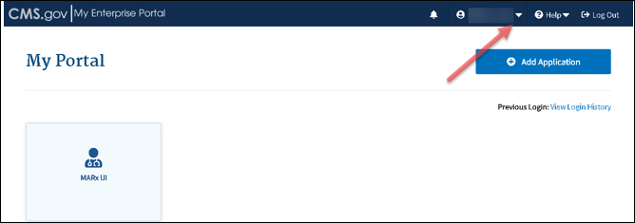
3 | Select My Access.  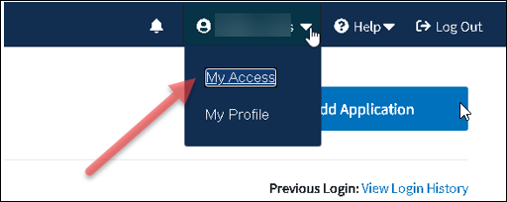
4 | Click Select Action dropdown and then click View/Modify Role Details.  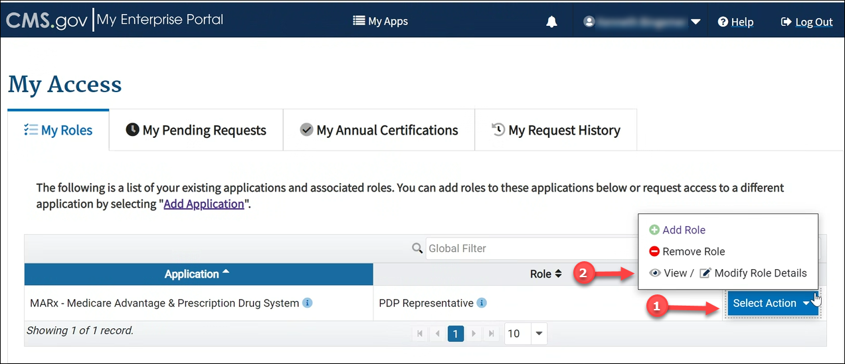
5 | Select Modify.  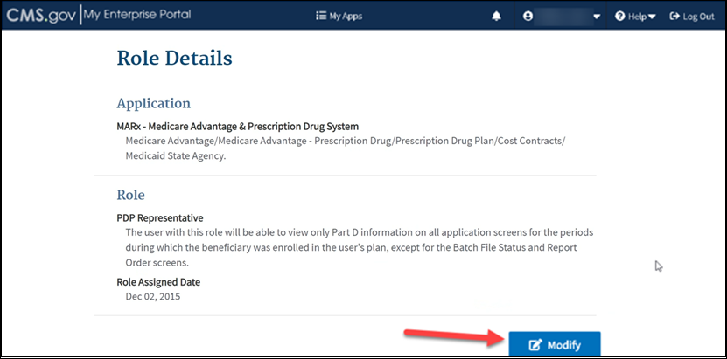
6 | Enter the following information:  - Plan Contact Number - Scroll to the end of the list add a comma (,), space and type Plan Contract Number. (Example: S5601, S2893)  - Reason for Request - Needed for role  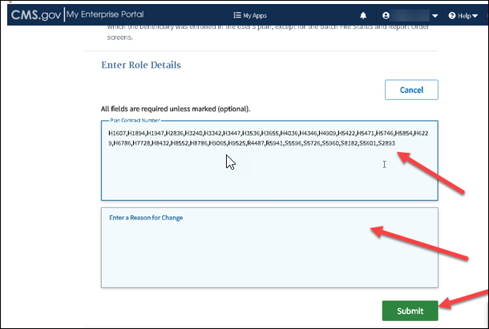
7 | Select Submit.  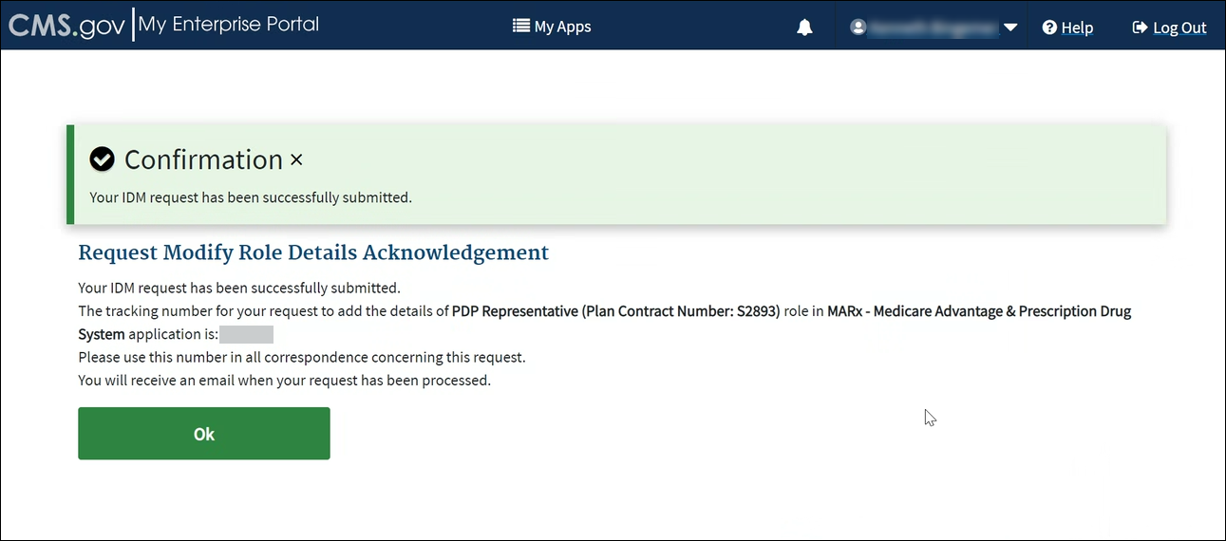  Result: System will provide a confirmation that your request has been submitted.
8 | Select OK.  Note: You will receive an email within 2-3 business days advising if the access request has been approved or denied.

Top of the Document

How to Register a Multi Factor Authentication (MFA) Using an Email Address

It is a requirement to register a Multi Factor Authentication (MFA) device to retrieve the security code during the login process.
Step | Action
1 | Log into MARx. Refer to Logging into MARx.
2 | From the drop-down menu, select My Profile.  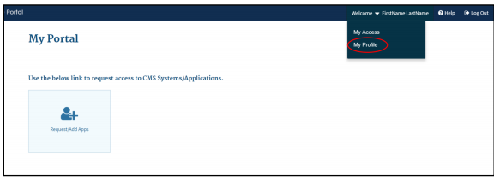
3 | Select Manage MFA Devices.  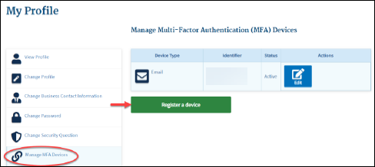
4 | Select Register a device.
5 | Expand the Select MFA Device drop down list and select E-mail.
6 | Enter “E-mail” or a brief description in the field labeled Enter MFA Device Description and click Submit.  Notes:  - Only two attempts are allowed to register your MFA device. If unable to register your device within two attempts, log out and then back in to try again.  - The e-mail address on your profile with be automatically used to obtain the Security Code.  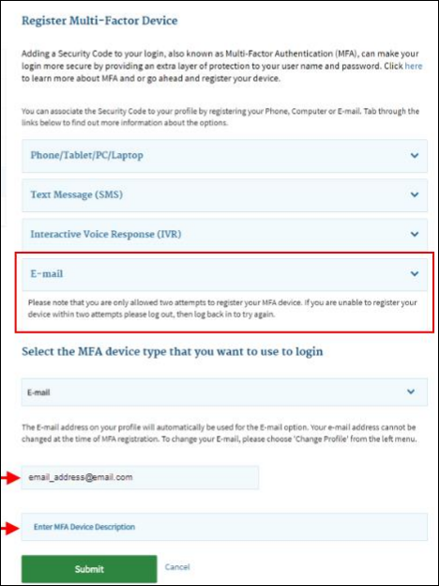
7 | You will receive a confirmation that the changes to your profile were submitted successfully.  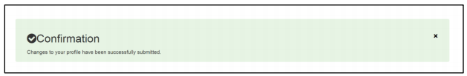

Top of the Document

Log Activity
MARx is a Read-only system.

While CCRs are not able to document in MARx, CCRs should document their MARx findings in PeopleSafe.

Top of the Document

Resolution Time
Approved MARx Initial Access Requests = within 72 hours of submission

Top of the Document

Related Documents
Parent SOP: CALL-0048: Medicare Part D Customer Care Call Center Requirements-CVS Caremark Part D Services, L.L.C.
Abbreviations/Definitions: Abbreviations / Definitions

Top of the Document
Not to Be Reproduced or Disclosed to Others without Prior Written Approval
ELECTRONIC DATA = OFFICIAL VERSION – PAPER COPY = INFORMATIONAL ONLY

